PCB Fuente Boost

Luis Felipe Narvaez Gomez. E-mail:luis.narvaez@usantoto.edu.co. Cod: 3120905. President of the EDS branch at IEEE.

Circuito simulado en Orcad Capture:

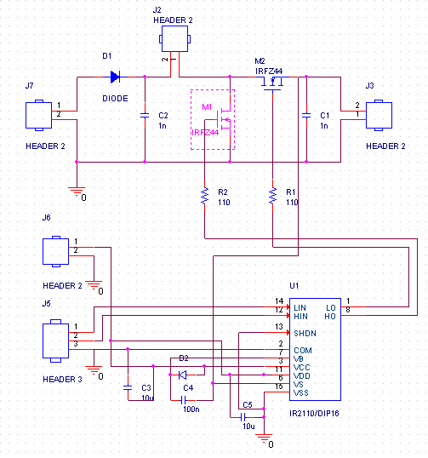

Parte de Potencia:



Elemento Vin / L1 / Vout

|  |  |
| --- | --- |
| *Tipo de elemento.* | Bornera de soldadura clasica |
| *Link de Pieza original* | Ya estaba adquirida |
| *Link de Pieza PCB* | https://co.mouser.com/ProductDetail/Molex/38660-8802?qs=sGAEpiMZZMsntO7gZZwOWBznzzIjRi3IH61qEmgvOKA%3D |
| *Nombre del footprint (. dra)* | MATCH = *386608802* |
| *Captura Pieza PCB (PCB Editor)* |  |
| *Captura Footprint (Orcad capture, Edit properties)* |  |

Elemento Diode

|  |  |
| --- | --- |
| *Tipo de elemento.* | Diodo Schottky de 30V a 1.5A |
| *Link de Pieza original* | https://co.mouser.com/ProductDetail/ROHM-Semiconductor/RB070MM-30TFTR?qs=sGAEpiMZZMtQ8nqTKtFS%2FE7Jc%252BkgrGbhj5NtjF4N4eumeRia9cw2Rg%3D%3D |
| *Link de Pieza PCB* | https://co.mouser.com/ProductDetail/ROHM-Semiconductor/RB070MM-30TR?qs=sGAEpiMZZMtQ8nqTKtFS%2FAMVnuj6LdzJqHiDvxvqJQ5Nqfl9nrPiog%3D%3D |
| *Nombre del footprint (. dra)* | MATCH = *SODFL3516X90N* |
| *Captura Pieza PCB (PCB Editor)* |  |
| *Captura Footprint (Orcad capture, Edit properties)* |  |

Elemento C2 / C1

|  |  |
| --- | --- |
| *Tipo de elemento.* | Condensador de acople de panel |
| *Link de Pieza original* | https://co.mouser.com/ProductDetail/KEMET/T140B156K030AS?qs=sGAEpiMZZMsh%252B1woXyUXj%252BguyZSUZJF6weIXQf%252Bu7V8%3D |
| *Link de Pieza PCB* | https://co.mouser.com/ProductDetail/Vishay-Sprague/T59EE157M030C0075?qs=sGAEpiMZZMsh%252B1woXyUXj26rP3PMWsryuJHVz%252BDTtY0%3D |
| *Nombre del footprint (. dra)* | MATCH = *CAPPC7343X430N* |
| *Captura Pieza PCB (PCB Editor)* |  |
| *Captura Footprint (Orcad capture, Edit properties)* |  |

Elemento Mosfet M1

|  |  |
| --- | --- |
| *Tipo de elemento.* | Mosfet IRFZ44 |
| *Link de Pieza original* | https://co.mouser.com/ProductDetail/Infineon-IR/IRFZ44NSTRLPBF?qs=sGAEpiMZZMshyDBzk1%2FWi5%252BqVgN3%252BWS8chPXfhMDXgQ%3D |
| *Link de Pieza PCB* | https://co.mouser.com/ProductDetail/Infineon-IR/IRFZ44VZSPBF?qs=sGAEpiMZZMvsw8vHdI9FuoGtrn2MU9DV |
| *Nombre del footprint (. dra)* | MATCH = *d2pak_to-263ab_* |
| *Captura Pieza PCB (PCB Editor)* |  |
| *Captura Footprint (Orcad capture, Edit properties)* |  |

Elemento Resistencias

|  |  |
| --- | --- |
| *Tipo de elemento.* | Resistencias a Gate de Mosfet |
| *Link de Pieza original* | https://co.mouser.com/ProductDetail/KOA-Speer/SG73G1JTTD20R0D?qs=sGAEpiMZZMtlubZbdhIBIFC33eDTuoa69JzZZEd4%2Fpc%3D |
| *Link de Pieza PCB* | https://co.mouser.com/ProductDetail/Vishay-Dale/CRCW120620R0FKEAC?qs=sGAEpiMZZMtlubZbdhIBIIZe04wfiaJWRZ0aKsAnSF4%3D |
| *Nombre del footprint (. dra)* | MATCH = *RESC3216X60N* |
| *Captura Pieza PCB (PCB Editor)* |  |
| *Captura Footprint (Orcad capture, Edit properties)* |  |

Parte del Driver

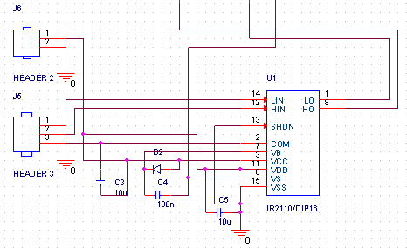

Elemento LIN-HIN-Ground

|  |  |
| --- | --- |
| *Tipo de elemento.* | Bornera de tres pines para señal de entrada al Driver. |
| *Link de Pieza original* | -Viene con ORCAD- |
| *Link de Pieza PCB* | -Viene con ORCAD- |
| *Nombre del footprint (. dra)* | MATCH = *jumper3* |
| *Captura Pieza PCB (PCB Editor)* |  |
| *Captura Footprint (Orcad capture, Edit properties)* |  |

Elemento Power

|  |  |
| --- | --- |
| *Tipo de elemento.* | Bornera de dos pines , para alimentación del Driver. |
| *Link de Pieza original* | -Viene con ORCAD- |
| *Link de Pieza PCB* | -Viene con ORCAD- |
| *Nombre del footprint (. dra)* | MATCH = *jumper2* |
| *Captura Pieza PCB (PCB Editor)* |  |
| *Captura Footprint (Orcad capture, Edit properties)* |  |

Elemento C3 / C5

|  |  |
| --- | --- |
| *Tipo de elemento.* | Condensador Driver |
| *Link de Pieza original* | https://co.mouser.com/ProductDetail/Taiyo-Yuden/TMK212BBJ106MGHT?qs=sGAEpiMZZMsh%252B1woXyUXj6Ion9DcW8uk%2FCsbgn7gICc%3D |
| *Link de Pieza PCB* | https://co.mouser.com/ProductDetail/Taiyo-Yuden/TMK212BBJ106MGHT?qs=sGAEpiMZZMsh%252B1woXyUXj6Ion9DcW8uk%2FCsbgn7gICc%3D |
| *Nombre del footprint (. dra)* | MATCH= *CAPC2012X135N* |
| *Captura Pieza PCB (PCB Editor)* |  |
| *Captura Footprint (Orcad capture, Edit properties)* |  |

Elemento C4

|  |  |
| --- | --- |
| *Tipo de elemento.* | Capacitor Driver |
| *Link de Pieza original* | https://co.mouser.com/ProductDetail/TDK/C1005X5R1E105K050BE?qs=sGAEpiMZZMsh%252B1woXyUXj9oLG36q6B9%2FTMDT%252BCXYWFU%3D |
| *Link de Pieza PCB* | https://co.mouser.com/ProductDetail/TDK/C1005X5R1E105K050BE?qs=sGAEpiMZZMsh%252B1woXyUXj9oLG36q6B9%2FTMDT%252BCXYWFU%3D |
| *Nombre del footprint (. dra)* | MATCH = *CAPC1005X55N* |
| *Captura Pieza PCB (PCB Editor)* |  |
| *Captura Footprint (Orcad capture, Edit properties)* |  |

Elemento Diode

|  |  |
| --- | --- |
| *Tipo de elemento.* | Diodo Schottky para Driver |
| *Link de Pieza original* | https://co.mouser.com/ProductDetail/ROHM-Semiconductor/RB070MM-30TFTR?qs=sGAEpiMZZMtQ8nqTKtFS%2FE7Jc%252BkgrGbhj5NtjF4N4eumeRia9cw2Rg%3D%3D |
| *Link de Pieza PCB* | https://co.mouser.com/ProductDetail/ROHM-Semiconductor/RB070MM-30TR?qs=sGAEpiMZZMtQ8nqTKtFS%2FAMVnuj6LdzJqHiDvxvqJQ5Nqfl9nrPiog%3D%3D |
| *Nombre del footprint (. dra)* | MATCH = *SODFL3516X90N* |
| *Captura Pieza PCB (PCB Editor)* |  |
| *Captura Footprint (Orcad capture, Edit properties)* |  |

Elemento IR2110

|  |  |
| --- | --- |
| *Tipo de elemento.* | Driver |
| *Link de Pieza original* | https://co.mouser.com/ProductDetail/Infineon-Technologies/IR2110STRPBF?qs=sGAEpiMZZMvsw8vHdI9Fujvp%2FaDqCohO |
| *Link de Pieza PCB* | https://co.mouser.com/ProductDetail/Infineon-Technologies/IR2110STRPBF?qs=sGAEpiMZZMvsw8vHdI9Fujvp%2FaDqCohO |
| *Nombre del footprint (. dra)* | MATCH = *SOIC127P1032X265-16N* |
| *Captura Pieza PCB (PCB Editor)* |  |
| *Captura Footprint (Orcad capture, Edit properties)* |  |

Listado de Componentes con PCB Footprint

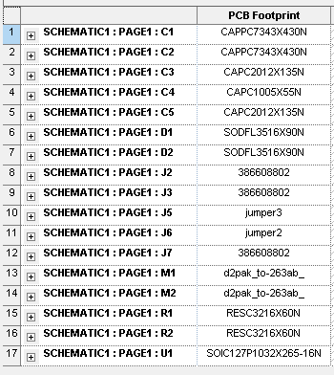

PCB EDITOR

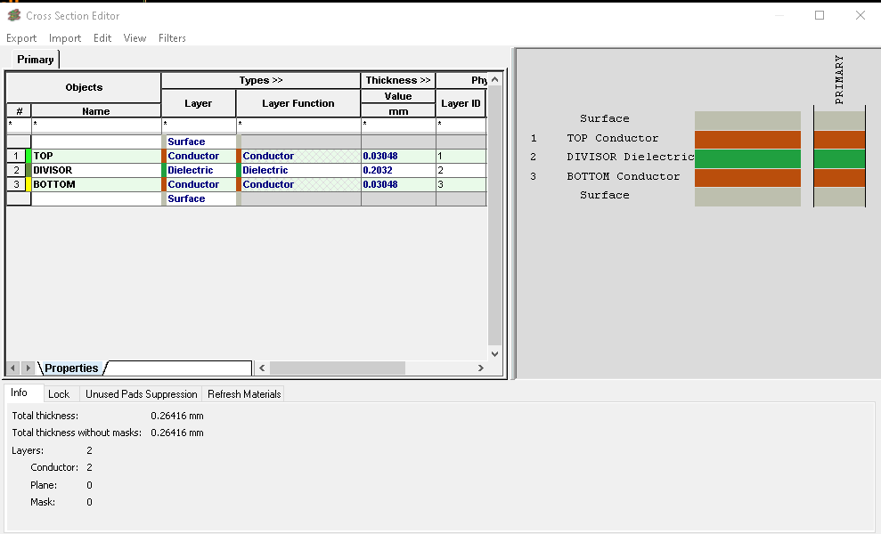

Orificios de montaje 1 (mounting_hole1).

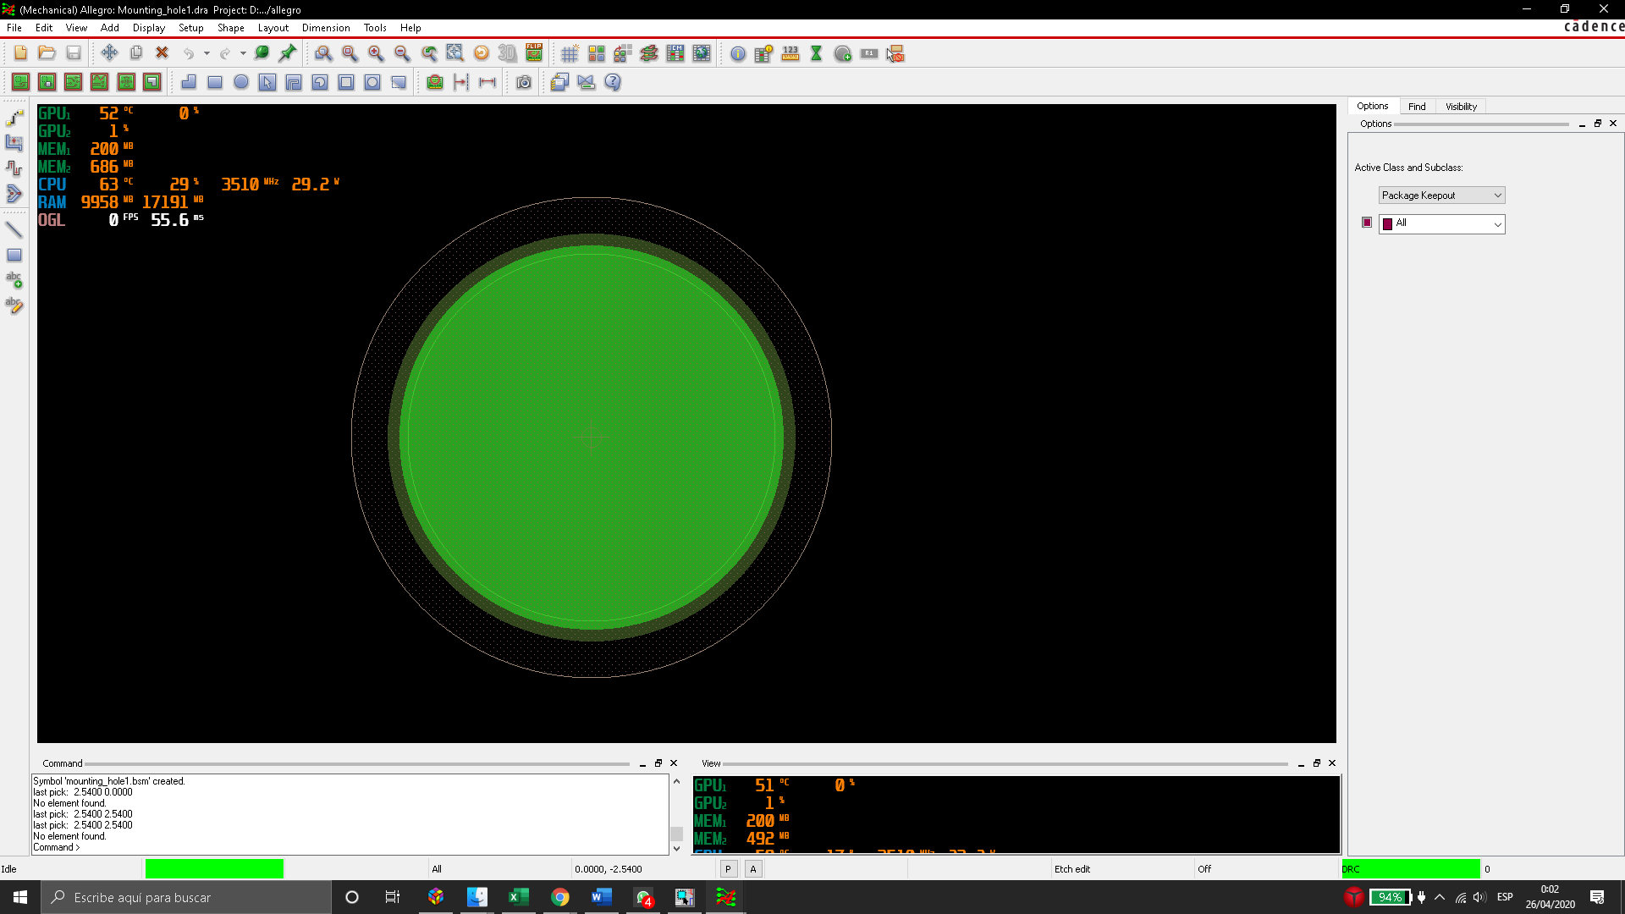

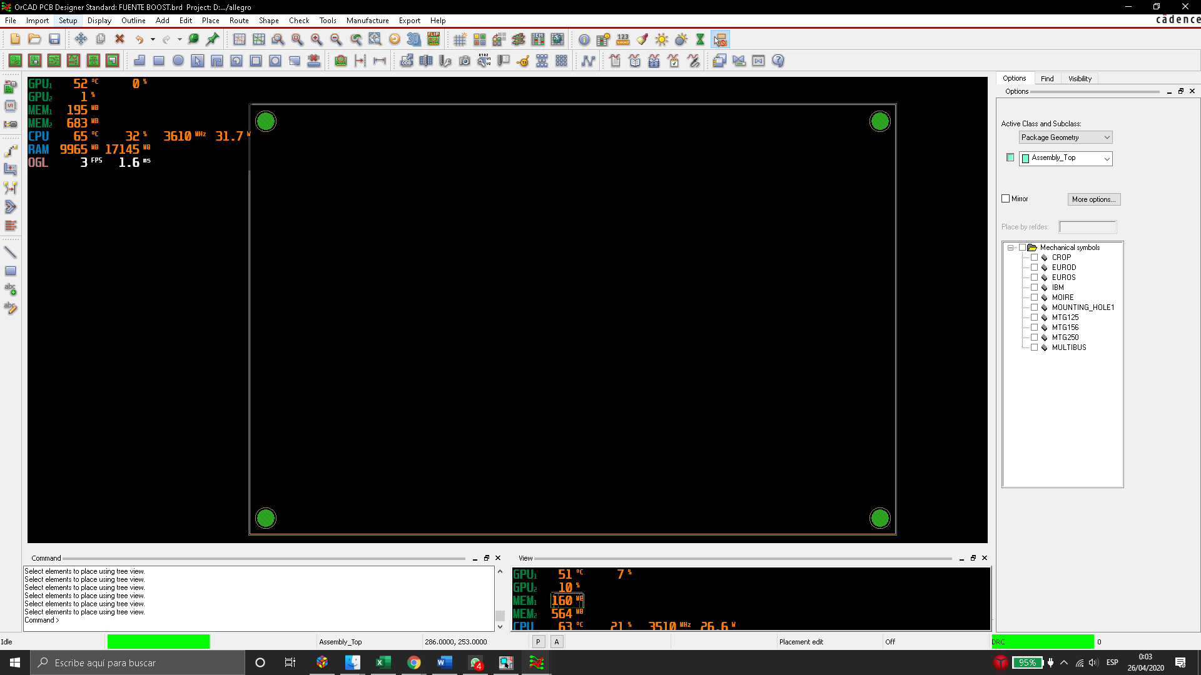

Componentes

Driver _ top /Potencia _ Button/Borneras _ top

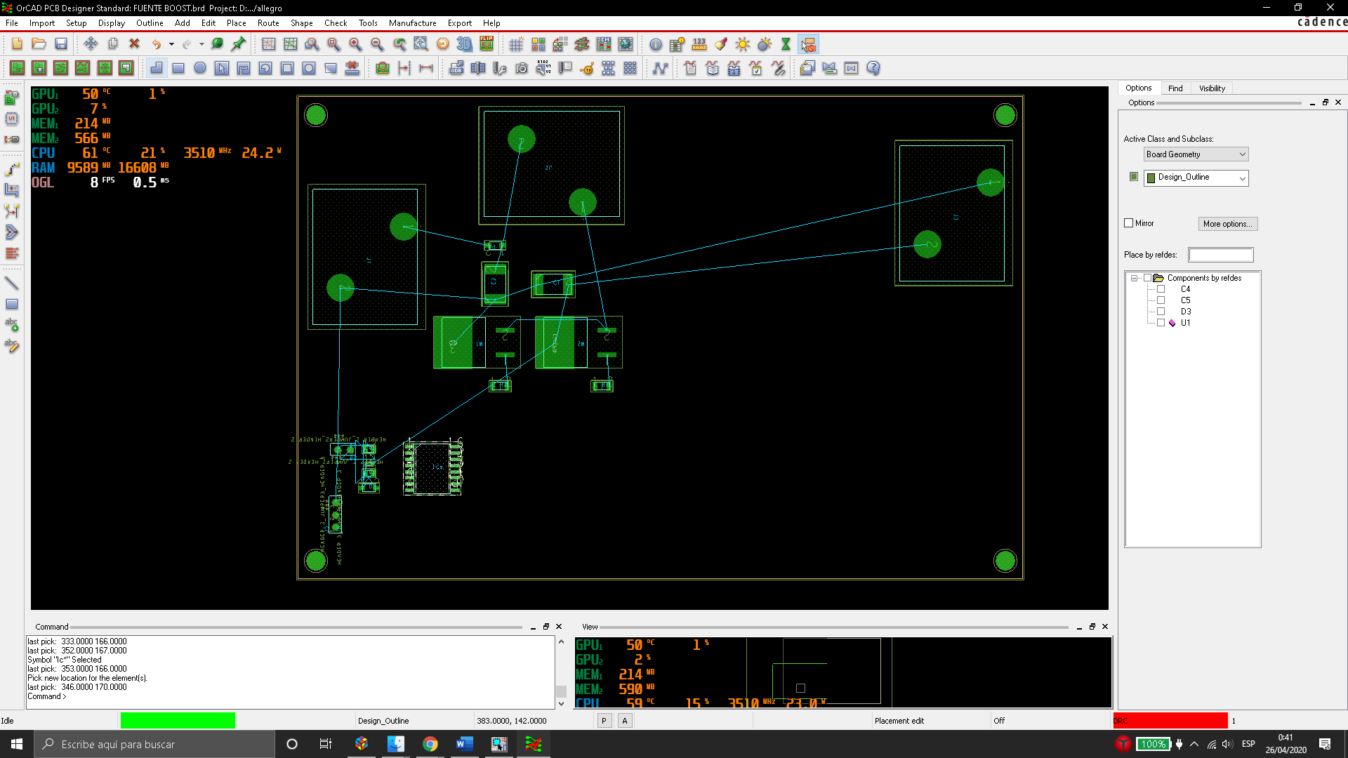

PCB 150mmx100mm con componentes.

